*Ulva* sp. as a hazardous material threatening the environment — A review

Gracjana Budzałek1, Kinga Wiśniewska3, Anna Dziubińska1, Sarah Postum2, Anna Woźniak4, and Sylwia Śliwińska-Wilczewska1,2,✉

1 Institute of Oceanography, University of Gdansk, 46 Pilsudskiego St, P81-378, Gdynia, Poland  
2 Department of Biology, Mount Allison University, 53 York St., Sackville, NB, E4L 1C9, Canada  
3 Department of Climatology and Atmosphere Protection, Faculty of Earth Sciences and Environmental Management, University of Wroclaw, Kosiby 8 St., 51–621 Wroclaw, Poland  
4 Department of Nursing and Midwifery, Wroclaw Medical University, Bartla 5 St., 51–618 Wroclaw, Poland

✉ Correspondence: [Sylwia Śliwińska-Wilczewska <[sylwia.sliwinska-wilczewska@ug.edu.pl](mailto:sylwia.sliwinska-wilczewska@ug.edu.pl)>](mailto:sylwia.sliwinska-wilczewska@ug.edu.pl)

# Abstract

*Ulva* sp. is a hazardous material widely distributed in oceans and estuaries worldwide, posing a significant environmental threat. Massive blooms, commonly referred to as Green Tides, have increased in frequency globally, driven by factors such as light availability, nutrient enrichment, rising sea surface temperatures, and salinity fluctuations. These blooms vary in location, species composition, ecological consequences, and underlying causes. Additionally, *Ulva* sp. produces bioactive compounds that inhibit growth and disrupt vital functions in various plant and animal species. This review summarizes current knowledge on *Ulva* sp., highlighting instances of harmful Green Tides over the past five decades, their detrimental effects on micro- and macroorganisms, and the hazardous compounds involved. Furthermore, we emphasize the need for interdisciplinary research to better understand the ecological risks associated with *Ulva* sp. and its potential implications for human health.

# Introduction

Aquatic green macroalgae *Ulva* is a genus that raises a lot of controversy. *Ulva* is a species that has recently been intensively promoted, especially in scientific journals focusing on the optimization and commercialization of new organisms for commercial purposes. Mass cultivation of *Ulva* sp. in outdoor open cultivation ponds of 1000 m2 can produce approximately 10 tons of dry biomass per year [1]. *Ulva* sp. has gained recognition as a profitable food source, cosmetic product, or as an environmental bioremediation agent due to its ability to absorb large amounts of heavy metals and other hazardous pollutants [1,2].

However, despite its nutritional and commercial benefits, *Ulva* sp. poses environmental and potential health risks that merit caution and consideration. Unfortunately, the lack of sufficient knowledge about the ecophysiology of *Ulva* sp. and unified rules and methods for obtaining biomass may lead to numerous abuses. For instance, it is possible to use *Ulva* biomass from sewage treatment plants or dead thallus obtained after bloom event as a source of cosmetics or food products. It has now become a fact that algae-based food supplements may be harmful to human health due to the high content of heavy metals including cadmium (Cd), lead (Pb), or mercury (Hg) [3].

It is well-established that *Ulva* sp. produces a diverse array of harmful secondary metabolites. Nevertheless, the extent of their hazardous effects on the surrounding ecosystem remains uncertain. Given the ability of *Ulva* sp. to inhibit the growth of competing algal and plant species, as well as to cause the mortality of various animal taxa, including vertebrates, an important question arises whether *Ulva* sp. is actually a safe and beneficial organism, or rather a threat to the environment.

Here, we reviewed the general classification and morphological differences of the *Ulva* genus and the locations of occurrence and physiological features that help this green algae adapt to changing environmental conditions. Next, we summarized available reports on the locations of *Ulva* sp. blooms in aquatic ecosystems and their broad consequences. We also presented the most frequently used methods for testing the biological activity of *Ulva* sp. and their active compounds that affect the surrounding ecosystem. At the end, we compiled reports on the harmful effects of *Ulva* on viruses, bacteria, fungi, micro- and macroalgae, as well as invertebrates and vertebrates. This article highlights the need for interdisciplinary research aimed at shedding light on the basic mechanisms governing the occurrence and succession of green algae in coastal seas as well as drawing the attention of the public to the fact that *Ulva* sp. is an organism that poses a real threat to the functioning of the aquatic environment and causes financial damage in a global scale.

# Classification and morphology of *Ulva* sp.

The genus *Ulva* was first described by Carolus Linnaeus in Species Plantarum [4]. In modern classification, *Ulva* belongs to the phylum Chlorophyta, class Ulvophyceae (K.R. Mattox & K.D. Stewart), order Ulvales (Blackman & Tansley), and family Ulvaceae (J.V. Lamouroux ex Dumortier) [5]. Phylogenetic studies have merged *Ulva* and *Enteromorpha* into a single genus [6,7], with 102 taxonomically accepted species worldwide [5]. The most commonly occurring *Ulva* species are shown in Fig. 1.

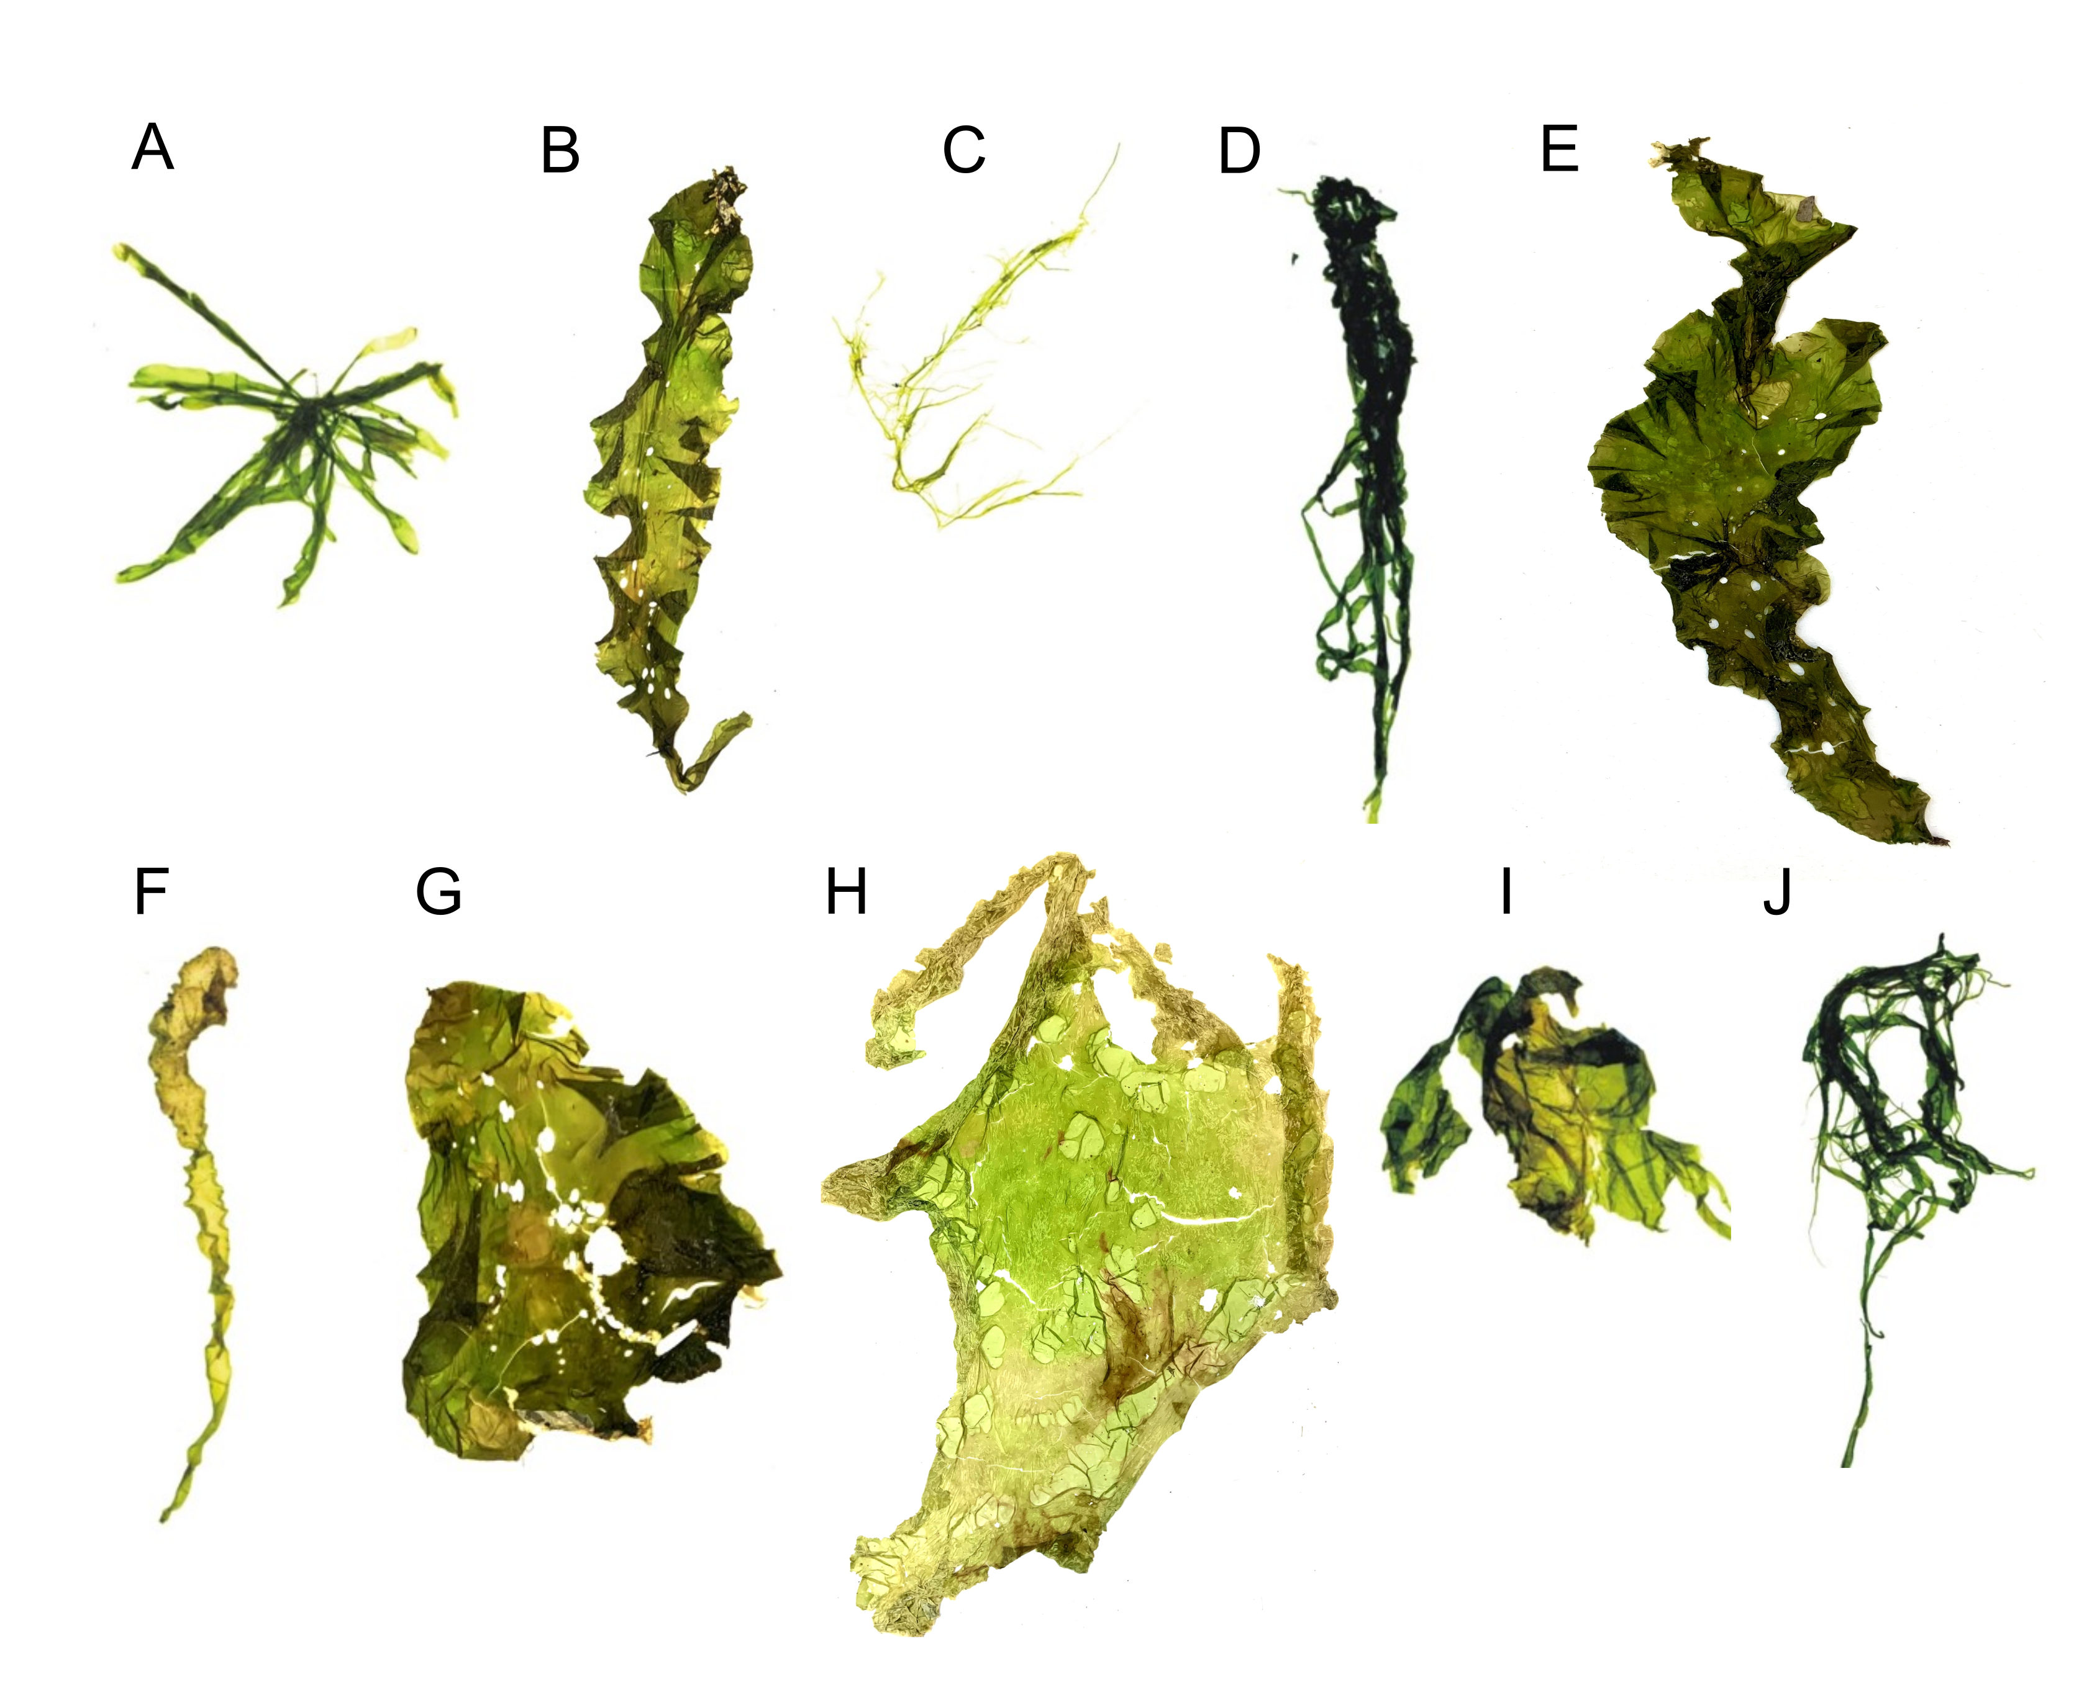

**Fig.** 1: Morphology of common *Ulva* species: (A) *Ulva compressa*; (B) *Ulva fasciata*; (C) *Ulva flexuosa*; (D) *Ulva intestinalis*; (E) *Ulva lactuca*; (F) *Ulva linza*; (G) *Ulva lobata*; (H) *Ulva ohnoi*; (I) *Ulva prolifera*; (J), or *Ulva rigida*.

Historically, species identification relied on morphological and anatomical traits, including thallus shape and size, presence of dentation, thickness, cell structure, and number of pyrenoids. However, these characteristics can be highly variable due to factors such as age, reproductive state, grazing pressure, and environmental conditions [5]. Consequently, molecular markers are increasingly used for taxonomic classification, leading to the discovery of new free-floating *Ulva* species associated with Green Tides [8–11].

The mature *Ulva* sp. thallus consists of a flattened, distromatic blade, where two layers of independent but closely associated cells form the structure. Thallus morphology varies widely, ranging from broad, irregularly lobed blades to linear, lanceolate, or oblanceolate shapes. Some species, such as *U. reticulata*, have perforated blades, while others, like *U. rigida*, *U. scandinavica*, and *U. taeniata*, remain unperforated. The thallus can grow up to one meter under optimal conditions [5]. Pigmentation varies from dark green to pale yellow, and vegetative cells contain a single chloroplast and one or more pyrenoids. Starch content, which serves as a reserve material, fluctuates between 1.59% and 21.44%, depending on growth conditions and seasonality [12].

Morphological variation in *Ulva* sp. is influenced not only by physical and chemical environmental factors but also by microbial associations. Major bacterial groups such as Bacteroidetes and Planctomycetes colonize U. australis surfaces [13], and similar bacterial communities have been found in *Ulva* sp. from different habitats [14]. The interaction between *Ulva* sp. and bacteria is crucial for normal morphological development. In axenic culture, *Ulva* sp. loses its typical form, but co-cultivation with bacterial isolates restores its normal structure [15]. Spoerner et al. [16] demonstrated that regulatory compounds secreted by Cytophaga MS6 (with auxin-like activity) and Roseobacter MS2 (with cytokinin-like activity) influence the growth and morphogenesis of *U. mutabilis*.

# Occurrence and physiology of *Ulva*

*Ulva* is a cosmopolitan genus found in oceans and estuaries worldwide [5]. Its successful colonization across diverse environments is attributed to physiological, biochemical, and molecular adaptations. *Ulva* sp. is distributed across all seven continents, including Antarctica. Asia records the highest species diversity with 56 species, followed by Australia (40 species), Europe (38 species), North America (34 species), Africa (31 species), South America (20 species), and Antarctica (12 species) [2].

The broad distribution of *Ulva* sp. is due to its remarkable tolerance and adaptation to key environmental factors such as light, temperature, and salinity. It can thrive in both freshwater and marine habitats. Marine species typically inhabit coastal zones to depths of 40 meters [17], while freshwater species have been documented in central Europe (e.g., *Ulva flexuosa*; [18]) and on Japan’s Ryukyu Islands (*Ulva limnetica*; [19]). Additionally, species like *Ulva lactuca*, *Ulva rigida*, *Ulva compressa*, and *Ulva pertusa* can tolerate salinity gradients ranging from less than 0.5 to 49 PSU [20]. Seasonal growth patterns show increased abundance during spring and summer, as warmer temperatures enhance growth and reproduction [21,22]. For instance, the optimal temperature for spore/gamete release and growth in *U. prolifera* is 20–27°C [23], with blooms typically occurring at 23–26°C [24]. Moreover, *Ulva* sp. exhibits a linear growth response to light intensity up to 30 μmol photons m−2s−1, reaching saturation above 70 μmol photons m−2s−1 [25]. Its opportunistic nature—marked by rapid nutrient uptake and fast growth rates—can lead to explosive increases in biomass [26,27]. Wu et al. [28] noted that the formation of air sacs in *Ulva* is influenced by adaptive changes in temperature and light, while settlement in U. prolifera is triggered by temperatures exceeding the optimal range. *Ulva* sp. reproduces both sexually and asexually. Its sexual cycle is characterized by an isomorphic alternation of generations, with morphologically similar but genetically distinct sporophyte and gametophyte phases. In addition, *Ulva* sp. can reproduce asexually through biflagellate zoospores and by parthenocarpy, enhancing its reproductive versatility [2]. The haploid thallus typically contains between 5 and 13 chromosomes [5]. Adaptation of the light-harvesting pigments is another key physiological feature. *Ulva* sp. contains chlorophyll *a* along with accessory pigments such as chlorophyll *b* and carotenoids (Fig. 2). Recent analyses of absorption spectra and chromatographic retention times have confirmed the presence of carotenoids including lutein, *β*-carotene, neoxanthin, *β*-cryptoxanthin, violaxanthin, antheraxanthin, and zeaxanthin, although total pigment yield varies with species [29].

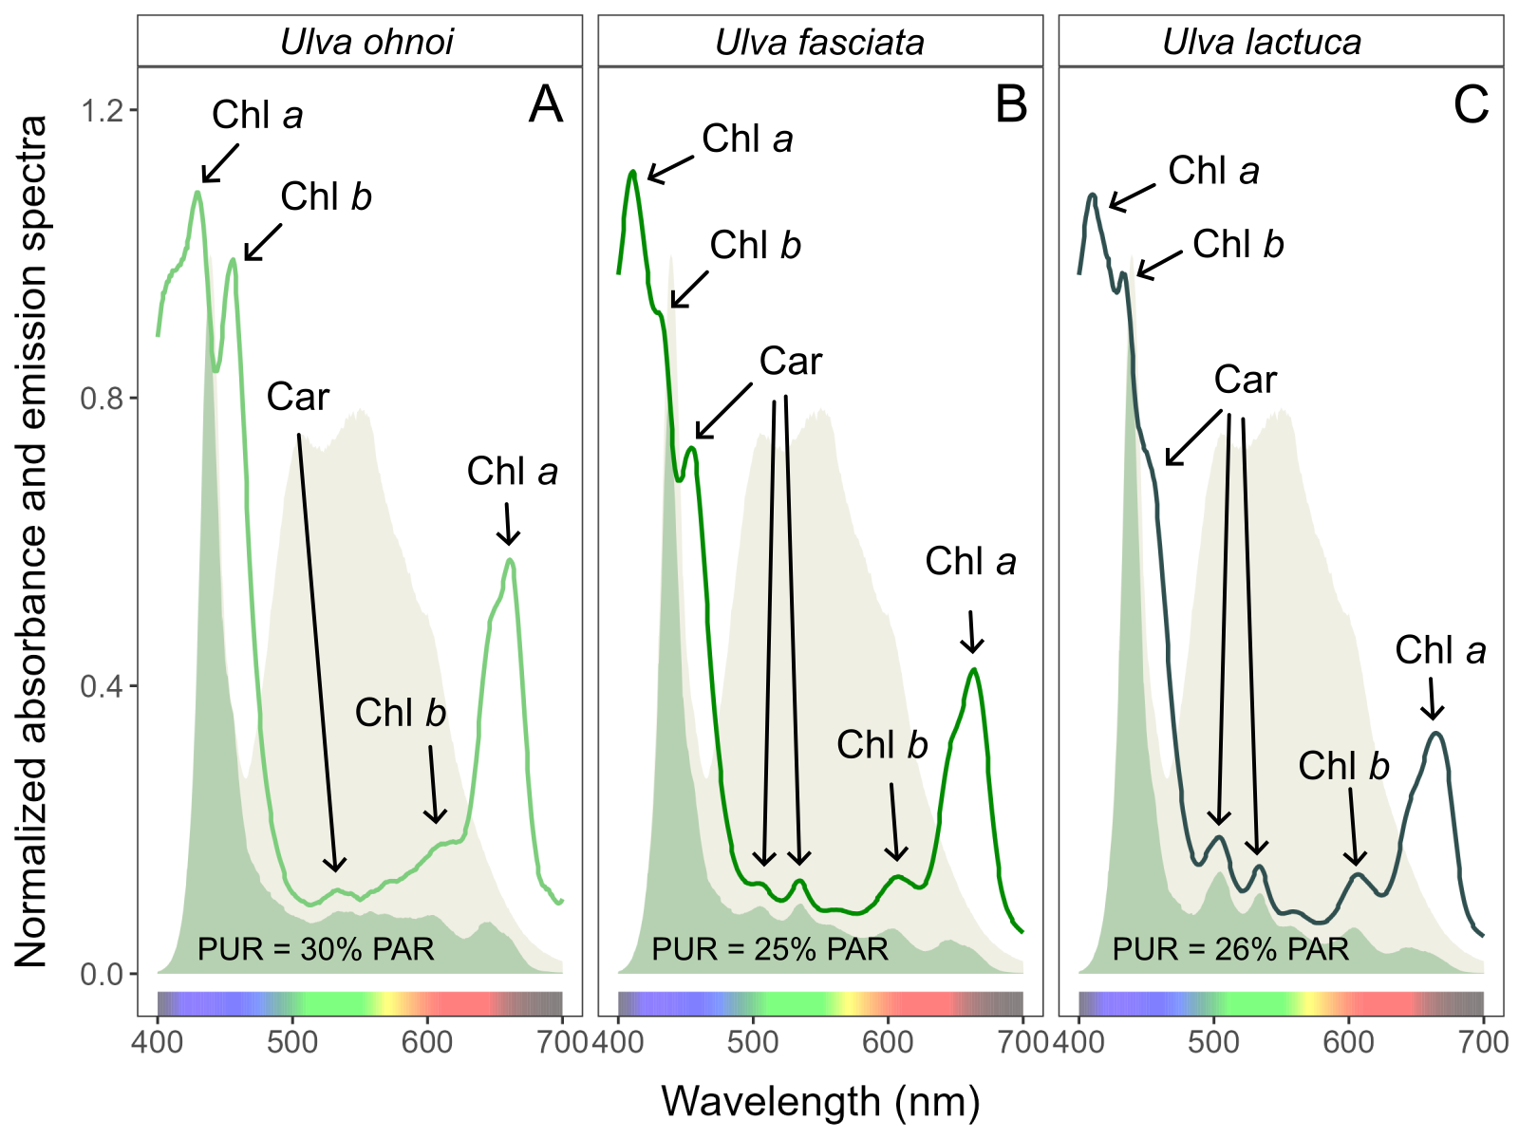

**Fig.** 2: Whole-cell absorbance spectra of (A) *Ulva ohnoi*; (B) *Ulva fasciata*; (C) *Ulva lactuca*, together with emission spectra of the white LED lamp (yellow area), normalized to emission at 440 nm, and PUR (green area). Peaks characteristic of known pigments are labeled: Chl *a*, chlorophyll *a*; Chl *b*, chlorophyll *b*; Car, carotenoids.

# Prevalence and consequences of *Ulva* blooms

*Ulva* is notorious for its rapid and uncontrolled proliferation, leading to phenomena known as Green Tides. Although these blooms share common traits, they vary widely in location, causative organisms, triggers, and impacts. Green Tides affect diverse sites and impose significant economic and environmental burdens, drawing attention from both scientists and policymakers [30]. In addition to adversely impacting tourism [31], large algal mats can create a hostile physico-chemical environment. These mats may blanket surfaces, alter sediment chemistry [32–34], induce sulfide poisoning [33], and generate anoxic conditions at the water-sediment interface [35]. They can also modify bird feeding behaviors [32], smother seagrass beds [36], and interfere with water use due to floating masses of detached algae. Additionally, they cause aesthetic issues such as odor nuisances and fouling of bathing waters [37,38], and can alter benthic algal communities [39,40]. The frequency of massive Green Tides has increased worldwide ([41]; Fig. 3). Until 1999, *Ulva* sp. blooms were primarily recorded in Europe, the USA, South Africa, and Japan. Over the past 25 years, however, these blooms have spread significantly, with only Australia and Antarctica yet to report such events (Fig. 3, Table 1). The dispersal of free-floating thallus fragments can initiate new blooms in previously unaffected areas, posing serious ecological and economic challenges. Notably, newly identified species such as *U. pseudo-ohnoi* sp. nov. have also been implicated in massive bloom events [42].

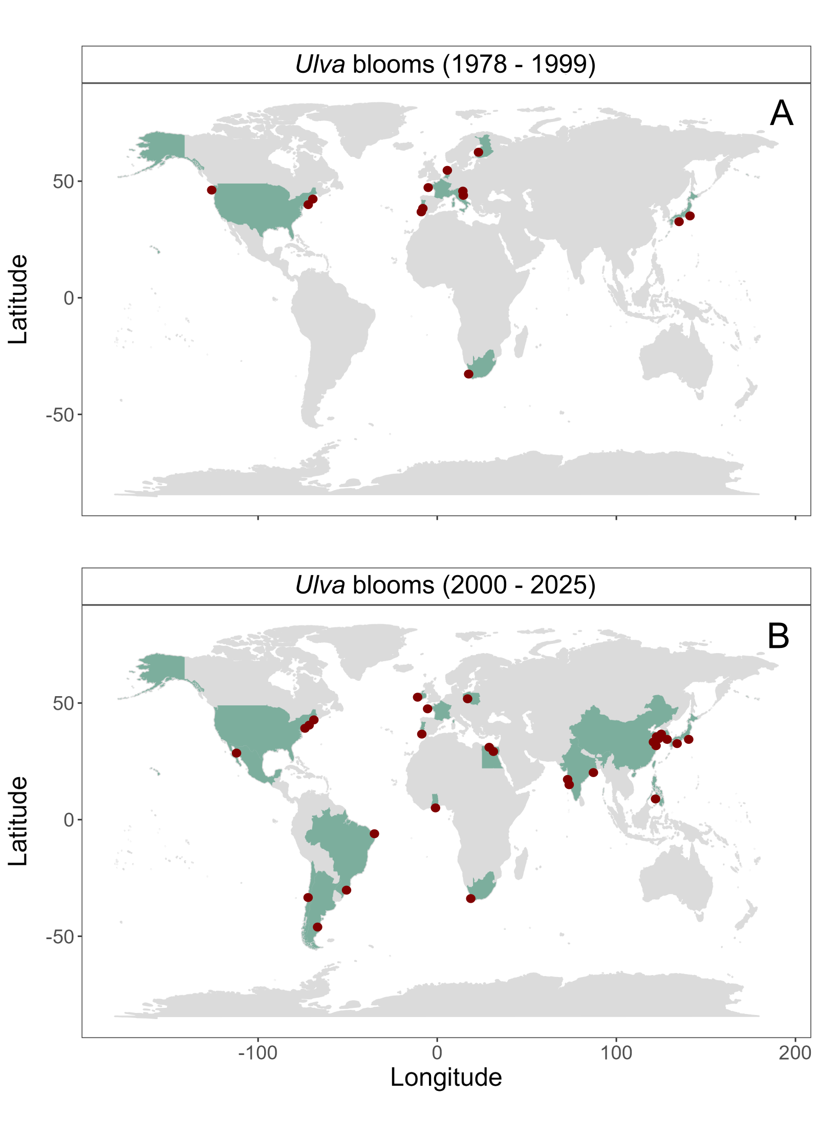

**Fig.** 3: Countries (green area), and specific places (red circles) where Ulva blooms were recorded before (top panel; A) and after (bottom panel; B) 2000.

Multiple factors contribute to the formation and persistence of *Ulva* sp. blooms. The widespread distribution of both microscopic and macroscopic stages of *Ulva* sp. plays a role in the global outbreak of Green Tides [43,44]. Excess nutrient inputs from agricultural runoff or wastewater discharge, combined with eutrophication, create ideal conditions for bloom formation [43]. Additionally, the high surface-to-volume ratio of *Ulva* sp. enhances its rapid growth [45], and conditions such as brackish salinity and a pH near 7.0 have been linked to significant increases in biomass [46]. Green Tides have become a major concern for scientists, environmental organizations, and policymakers striving to mitigate their impacts on marine ecosystems and coastal communities. These large-scale blooms, particularly prevalent in nutrient-rich coastal areas [47], can alter light availability for phytoplankton and benthic communities over prolonged periods [48]. For example, in the Venice Lagoon, a period of intense *Ulva* growth in the late 1980s was followed by a subsequent decline, which dramatically altered local conditions [38]. Furthermore, as *Ulva* biomass decomposes and sinks, oxygen depletion can lead to localized hypoxic “dead zones” [49].

Economic damages from *Ulva* sp. blooms are also significant. For instance, blooms of *U. lactuca* in coastal waters near urbanized and agricultural regions like Maui, Hawaii, result in annual losses exceeding 20 million dollars [50,51]. In Brittany, France, a Green Tide event led to the accumulation of 100,000 tonnes of *Ulva* biomass (primarily *U. armoricana* and *U. rotundata*), costing an estimated US 10–150 per tonne in cleaning and disposal expenses [38]. Similarly, in 2008, a 30-kilometer-long bloom of *U. prolifera* along the Qingdao coast in China required the disposal of over 1 million tonnes of biomass at a cost of US 30 million, employing 10,000 individuals [2,30,52]. The emergency response costs prior to the 2008 Beijing Olympic Games sailing competition in Qingdao were estimated at around 200 million euros, amounting to 5.84% of Qingdao Municipality’s total income for that year [53].

**Table 1.** Examples of *Ulva* blooms reported in different parts of the world’s coastlines.

Dong et al. [54] Cai et al. [55] Zhang et al. [56] Liu et al. [57] Lü et al. [58] Gong et al. [2024], Xia et al. [2024], Zhang et al. [2019], Xu et al. [2014] Liu et al. [59] Su et al. [60] Feng et al. [61] Qi et al. [62] Hu et al. [63] Abduraup et al. [64] Liu et al. [65] Yoshida et al. [66] Choi et al. [67] Samanta et al. [68], Kang et al. [9] Lee et al. [42] Yabe et al. [69] Bast et al. [70] Bast et al. [70] Peter et al. [71]

Viaroli et al. [72], Viaroli et al. [73] Ménesguen et al. [74] Charlier et al. [38] Ménesguen et al. [75], Louis et al. [76], Jones et al. [44] Herrero et al. [77] Aníbal et al. [78] Rybak and Gąbka [79] Martins et al. [80] Malta and Verschuure [81], Malta et al. [48] Runca et al. [82] Sfriso et al. [83] Wan et al. [10] Bermejo et al. [84] Back et al. [85]

Xing et al. [86] Kennish et al. [87] Granger et al. [88] Guidone and Thornber [89] Chávez-Sánchez et al. [90] Nelson et al. [91]

Mutizabal-Aros et al. [92] Mutizabal-Aros et al. [93] Puppin-Gonçalves et al. [94] Lanari and Copertino [95] Becherucci et al. [96]

Human et al. [97] Anderson et al. [98] Allanson et al. [99] Hosny et al. [100] Ahmed et al. [101] Granger et al. [102]

# Methods of testing bioactivity of *Ulva*

To assess the impact of *Ulva* sp. on other organisms, researchers employ a variety of investigative approaches. Common methods include adding extracts, conducting experiments with fresh thalli, performing co-culture assays, and carrying out field observations. In many studies, several methods are applied simultaneously for comparative analysis. The most frequently used technique involves preparing extracts from dried *Ulva* sp. thalli. In this approach, a dry sample is ground and mixed with distilled water, seawater, or chemical reagents, followed by high-speed centrifugation or filtration. A specific dose of the resulting extract is then introduced to the target organism. A second method involves the use of cell-free filtrates. In this procedure, *Ulva* sp.—with a known biomass and maintained under controlled conditions—is cultivated for several days. The thalli are then removed, and the filtrate, containing bioactive compounds, is used to inoculate cultures of the target organisms. A third approach is the direct inoculation of fresh *Ulva* sp. thalli into cultures of the test organisms [23,103–108]. Additionally, isolation co-culture assays have been employed by Wang et al. [23] and Jin and Dong [103], whereby direct contact between the target species and *Ulva* sp. is prevented. Mesocosm experiments, using floating tanks deployed at the sampling site, allow *Ulva* sp. to be maintained under ambient conditions similar to its natural habitat [109]. Tang and Gobler [109] also conducted bottle incubation experiments as part of their field studies.

# The effect of *Ulva* on surrounding ecosystem

Evidence indicates that *Ulva* sp. exhibits significant bioactivity against a variety of heterotrophic microorganisms, microalgae, seaweeds, grazers, and other animals. Most research has focused on species such as *Ulva lactuca*, *U. fasciata*, and *U. rigida* (Fig. 4), with a detailed summary provided in the Supplementary Materials.

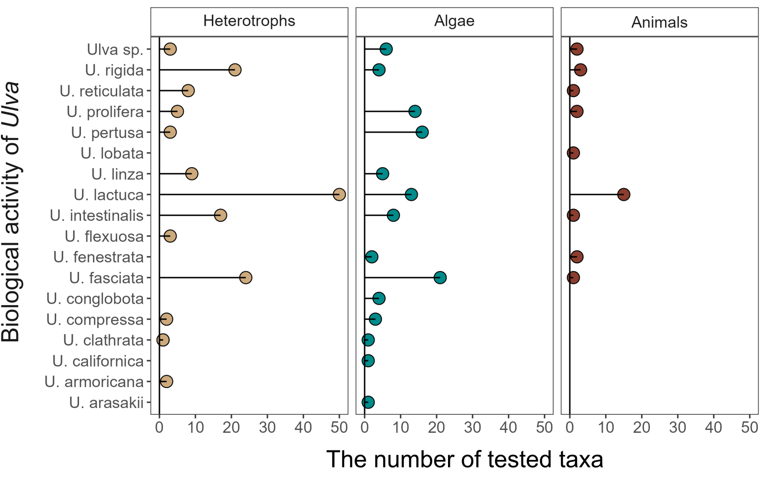

**Fig.** 4: Number of viruses, heterotrophic bacteria, fungi (Heterotrophs), micro- and macroalgae (Algae), invertebrates and vertebrates (Animals) affected by *Ulva* genus.

## *Ulva* sp. as a hazardous material affecting heterotrophic microorganisms

Research has demonstrated that various *Ulva* species can impact viruses, bacteria, and fungi (Figs. 5, 6, 7). Studies have documented effects on 20 different virus types, 22 heterotrophic bacterial types, and 28 fungal taxa, with *Ulva lactuca* being the most extensively tested—against 50 different taxa of heterotrophic microorganisms. Generally, these studies report a strongly or moderately inhibitory effect of *Ulva* compounds on microbial development. Notably, only certain species within the *Aspergillus* genus have exhibited growth stimulation under the influence of compounds secreted by *Ulva lactuca* (Figs. 7). Frequently tested bacteria include strains of *Bacillus*, *Escherichia*, and *Staphylococcus* (Figs. 6). Recent research also indicates that *Ulva* can actively inhibit viruses, including SARS-CoV-2 (Figs. 5).

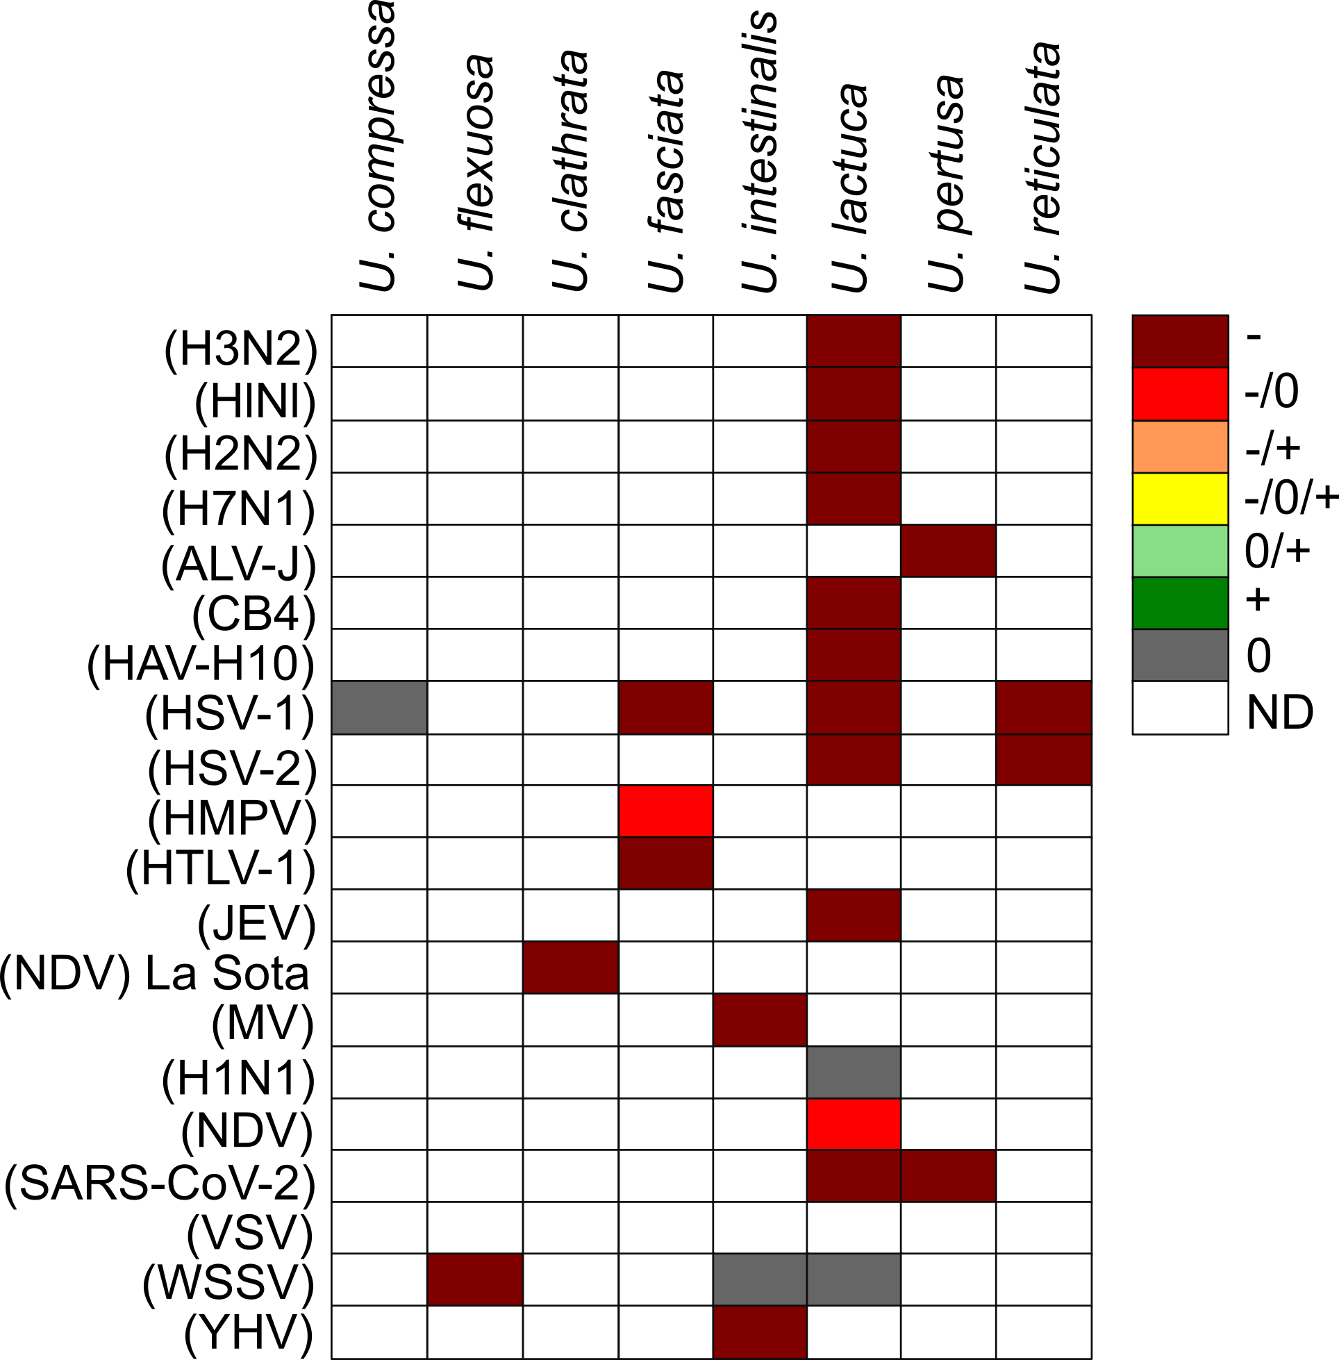

**Fig.** 5: The biological activity of *Ulva* against viruses.

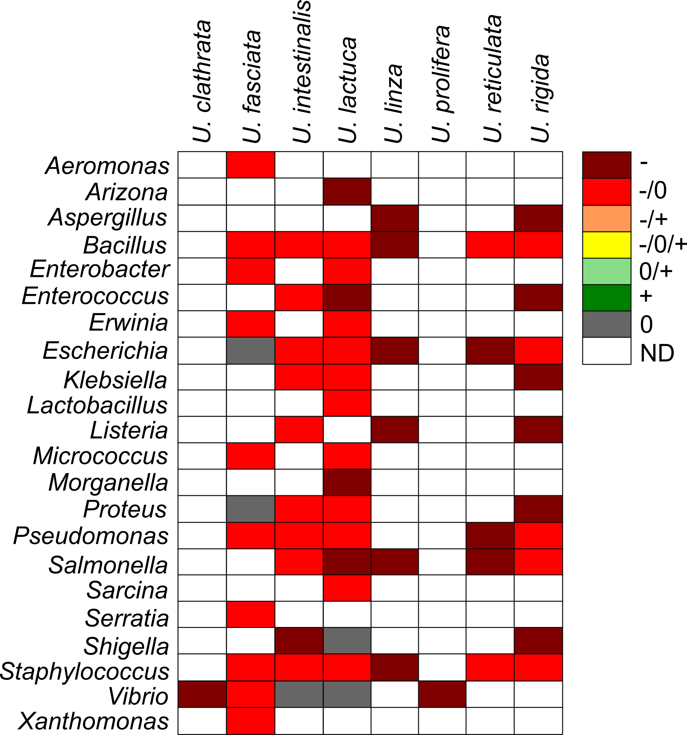

**Fig.** 6: The biological activity of *Ulva* against bacteria..

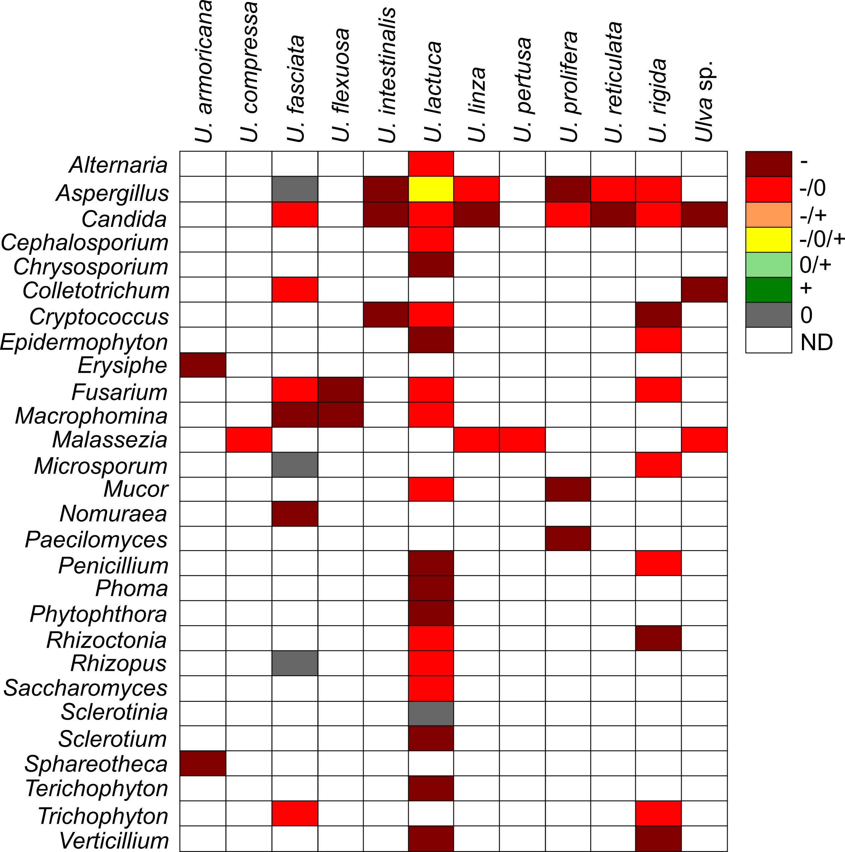

**Fig.** 7: The biological activity of *Ulva* against fungi.

## *Ulva* as a hazardous material affecting microalgae and seaweeds in the aquatic environment

Our comparative analysis reveals that both micro- and macroalgae constitute the largest group of organisms evaluated for the effects of *Ulva* compounds (Figs. 8). Testing has encompassed 21 taxa within Dinoflagellata, 17 within Heterokontophyta, 13 within Chlorophyta, 7 within Rhodophyta, 3 each from Cyanobacteria and Haptophyta, and single taxa from the Cryptista and Euglenophyta phyla. The majority of these organisms exhibit strong to moderate growth inhibition. Although a few studies suggest that *Ulva* may negatively affect marine vascular plants such as *Zostera* sp. [110], some reports indicate that compounds secreted by *Ulva* can positively influence terrestrial crops and vegetables; however, these effects appear to be of limited ecological significance.

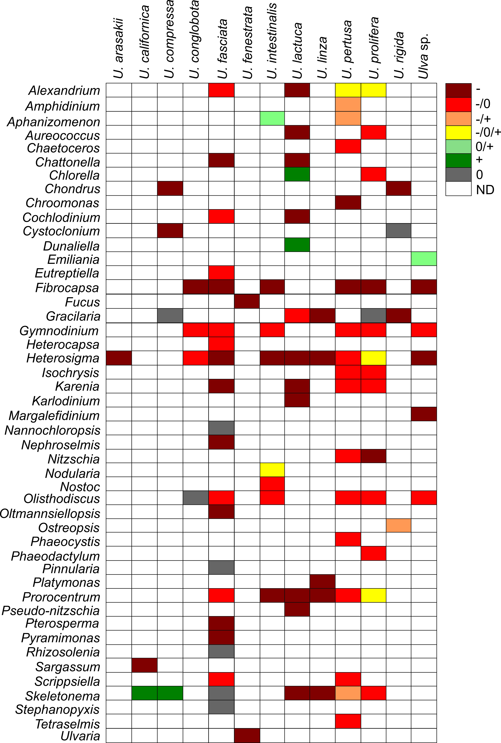

**Fig.** 8: The biological activity of *Ulva* against microalgae and macroalgae.

## *Ulva* as a hazardous material affecting invertebrates and vertebrates

Research indicates that *Ulva* sp. secretes compounds that adversely affect the development and physiology of various invertebrates and vertebrates (Figs. 4, 9); Supplementary Materials). Investigations have covered seven animal phyla: 14 taxa from Arthropoda, 8 from Mollusca, 4 from Chordata, and one taxon each from Rotifera, Echinodermata, Porifera, and Platyhelminthes. The majority of these studies report growth inhibition or mortality following exposure to *Ulva*-derived compounds. However, some taxa, including *Artemia*, *Brachionus*, *Cebidichthys*, *Inimicus*, and *Sparus*, have shown resistance. Conversely, species such as *Danio*, *Haliotis*, and *Litopenaeus* may experience growth stimulation under the influence of compounds from certain *Ulva* genera.

Additionally, *Ulva* sp. is typically free of macroinvertebrate colonization due to the production of antifouling agents in the thallus boundary layer. These waterborne toxic macromolecules originate both from the thalli and their associated epibiotic bacteria [111]. For example, *U. reticulata* secretes bioactive substances, supplemented by bacterial compounds, to repel fouling organisms [111,112]. Egan et al. [113] further reported that bacteria on the surface of *U. lactuca* inhibit the growth of bacteria, fungi, invertebrate larvae, and microalgae, although research in this area remains limited.

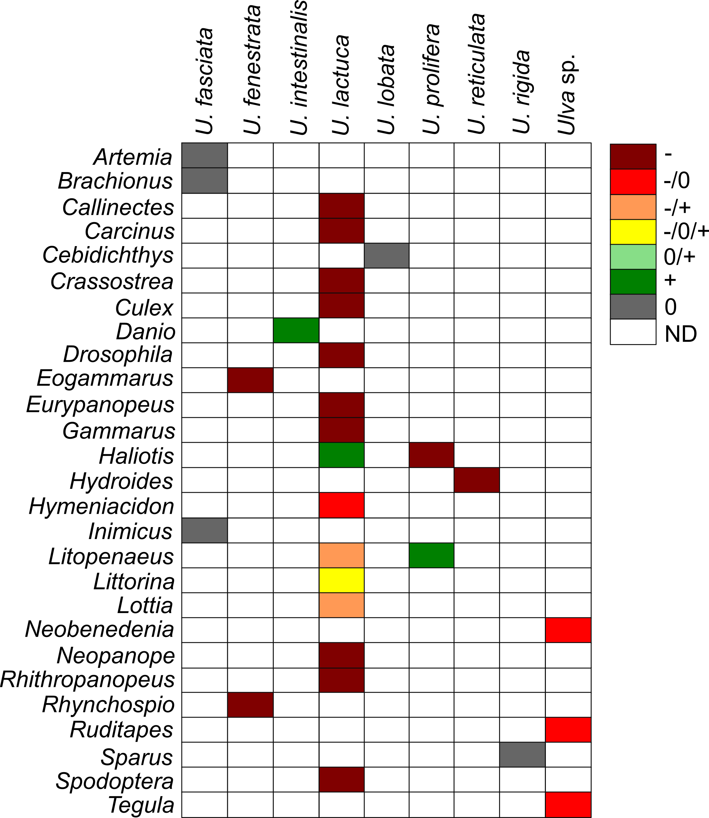

**Fig.** 9: The biological activity of *Ulva* against invertebrates and vertebrates.

# Active compounds and secondary metabolites of *Ulva* genus

*Ulva* sp. harbors a diverse array of bioactive compounds, many of which have yet to be fully characterized for their potential harmful effects. The thallus of *Ulva* sp. contains amino acids such as cysteinolic acid, cysteic acid, proline, glutamic acid, and chondrine [114]. It also comprises various secondary metabolites including terpenes, polyphenolic compounds, hexapeptides, diterpenoids, and steroids [115–121]. Notably, taurine—an amino acid present in *Ulva* sp.—has been shown to act as a broad-spectrum cytoprotective agent [122,123].

Moreover, *Ulva* sp. contains polyunsaturated fatty acids; extracts from *U. rigida* have demonstrated antimicrobial activity [124]. Sulphated polysaccharides, particularly Ulvan—a water-soluble compound constituting approximately 8–29% of the dry weight of *Ulva*—have been noted for their anticoagulant activity through thrombin inhibition and potentiation of heparin cofactor II [125]. Ulvan is also reported to possess anticancer, antiviral, hypocholesterolemic, hypolipidemic, and neuroprotective properties [126–130]. In contrast, Barakat et al. [131] reported that ulvan adversely affected microalgae and certain bacterial and fungal species, such as *Klebsiella pneumoniae*, *Staphylococcus epidermidis*, *Enterococcus faecalis*, and *Candida albicans*. Additionally, studies by Alamsjah et al. [132] indicated significant cell mortality in several microalgal taxa—caused by compounds from *U. fasciata* and *U. pertusa*—with tetraenoic acid and α-linolenic acid identified as key inhibitory agents. Lv et al. [107] further demonstrated that hexadecanoic acid, octadecatetrienoic acid, and octadecenoic acid produced by *U. linza* induce cell death in species such as *Prorocentrum minimum* and *Platymonas helgolandica*. These findings underscore that *Ulva* sp. synthesizes a range of secondary metabolites with potent bioactivities that may have deleterious effects on various organisms.

**Table 2.** Bioactive compounds produced by *Ulva* and their biological activity on tested organisms.

Mao et al. [125] Ismail et al. [124] Ito and Hori [122], Peña-Rodríguez et al. [123] Lv et al. [107] Alamsjah et al. [133], Alamsjah et al. [132] Barakat et al. [131]

# Conclusions

This review demonstrates that *Ulva* sp. is a globally distributed macroalga whose extensive physiological and molecular adaptations enable its widespread occurrence. Although *Ulva* sp. offers potential benefits for commercial applications such as food production, cosmetics, and bioremediation, its propensity to form massive blooms—known as Green Tides—poses significant environmental and economic challenges. The diverse methods employed to test the bioactivity of *Ulva* sp. reveal that its secondary metabolites have far-reaching inhibitory effects on heterotrophic microorganisms, microalgae, seaweeds, and even various invertebrates and vertebrates. These compounds, including amino acids, terpenes, polyphenolics, and sulphated polysaccharides, underscore the dual nature of *Ulva* sp. as both a resource and a hazardous material. The evidence presented highlights the critical need for further interdisciplinary research to elucidate the mechanisms underlying *Ulva* sp. blooms and to develop effective management strategies. Such efforts are essential to mitigate the ecological disruptions and economic losses associated with these events, while also safeguarding human health and the integrity of marine ecosystems. Ultimately, a balanced approach that integrates advanced molecular techniques with traditional ecological assessments will be key to addressing the complex challenges posed by *Ulva* sp.

# CRediT authorship contribution statement

**Gracjana Budzałek**: Writing – original draft, Resources, Methodology, Investigation, Data curation, Conceptualization. **Kinga Wiśniewska**: Writing – original draft, Validation, Resources, Methodology, Investigation, Data curation. **Anna Dziubińska**: Writing – original draft, Validation, Resources, Methodology, Investigation, Data curation. **Sarah Postuma** Resources, Investigation, Data curation. **Anna Woźniak**: Resources, Investigation, Data curation. **Sylwia Śliwińska-Wilczewska**: Supervision, Project administration, Writing – original draft, Resources, Methodology, Investigation, Data curation, Funding acquisition, Conceptualization, Validation.

# Declaration of Competing Interest

The authors declare that they have no known competing financial interests or personal relationships that could have appeared to influence the work reported in this paper.

# Acknowledgements

This work was supported by Canada Research Chair in Phytoplankton Ecophysiology (Douglass A. Campbell from Mount Allison University, Canada) and Latitude & Light; NSERC of Canada Discovery Grant (Douglass A. Campbell from Mount Allison University, Canada), and funded by DS. 531-O500-D717-25 (S.Ś-W.) and DS. 531-O402-D031-25 (A.D.).

# Data availability

Data supporting this study is available on: <https://github.com/FundyPhytoPhys/SynBaltic/Ulva> (public GitHub Repository).

Code to perform data processing and analyses is available at <https://github.com/FundyPhytoPhys/SynBaltic/Ulva>.

# References

[1] C. Simon, M. McHale, R. Sulpice, Applications of Ulva Biomass and Strategies to Improve Its Yield and Composition: A Perspective for *Ulva* Aquaculture, Biology 11 (2022) 1593. https://doi.org/[10.3390/biology11111593](https://doi.org/10.3390/biology11111593).

[2] V.A. Mantri, M.A. Kazi, N.B. Balar, V. Gupta, T. Gajaria, Concise review of green algal genus *Ulva* Linnaeus, Journal of Applied Phycology 32 (2020) 2725–2741.

[3] P. Rzymski, P. Niedzielski, N. Kaczmarek, T. Jurczak, P. Klimaszyk, The multidisciplinary approach to safety and toxicity assessment of microalgae-based food supplements following clinical cases of poisoning, Harmful Algae 46 (2015) 34–42.

[4] C. Linnaeus, Species plantarum, exhibentes plantas rite cognitas ad genera relatas, cum differentiis specificis, nominibus trivialibus, synonymis selectis, locis natalibus, secundum systema sexuale digestas, Impensis G.C. Nauk, 1797.

[5] M.D. Guiry, G.M. Guiry, AlgaeBase. World-wide electronic publication, National University of Ireland, Galway. 2017, (2017).

[6] H.S. Hayden, J. Blomster, C.A. Maggs, P.C. Silva, M.J. Stanhope, J.R. Waaland, Linnaeus was right all along: *Ulva* and *Enteromorpha* are not distinct genera, European Journal of Phycology 38 (2003) 277–294. https://doi.org/[10.1080/1364253031000136321](https://doi.org/10.1080/1364253031000136321).

[7] S. Shimada, M. Hiraoka, S. Nabata, M. Iima, M. Masuda, Molecular phylogenetic analyses of the Japanese *Ulva* and *Enteromorpha* (Ulvales, Ulvophyceae), with special reference to the free-floating *Ulva*, Phycological Research 51 (2003) 99–108. https://doi.org/[10.1111/j.1440-1835.2003.tb00176.x](https://doi.org/10.1111/j.1440-1835.2003.tb00176.x).

[8] M.A. Kazi, M.G. Kavale, V.V. Singh, Morphological and molecular characterization of *Ulva* *Chaugulii Sp. Nov* ., *U. Lactuca* and *U. Ohnoi* (Ulvophyceae, Chlorophyta) from India, Phycologia 55 (2016) 45–54. https://doi.org/[10.2216/15-11.1](https://doi.org/10.2216/15-11.1).

[9] E.J. Kang, A.-R. Han, J.-H. Kim, I.-N. Kim, S. Lee, J.-O. Min, B.-R. Nam, Y.-J. Choi, M.S. Edwards, G. Diaz-Pulido, Evaluating bloom potential of the green-tide forming alga *Ulva* *Ohnoi* under ocean acidification and warming, Science of the Total Environment 769 (2021) 144443.

[10] A.H. Wan, R.J. Wilkes, S. Heesch, R. Bermejo, M.P. Johnson, L. Morrison, Assessment and characterisation of Ireland’s green tides (Ulva species), PLoS One 12 (2017) e0169049.

[11] N. Krupnik, G.U.Y. Paz, J. DOUEK, E. LEWINSOHN, A. ISRAEL, N. CARMEL, F. MINEUR, C.A. MAGGS, Native, invasive and cryptogenic *Ulva* species from the Israeli Mediterranean Sea: Risk and potential, Mediterranean Marine Science 19 (2018) 132–146.

[12] M. Kazir, D. Gurevich, A. Groobman, M. Prabhu, Á. Israel, A. Golberg, Y.D. Livney, Physicochemical, rheological and digestibility characterization of starch extracted from the marine green macroalga *Ulva* *Ohnoi*, Food Hydrocolloids 120 (2021) 106892.

[13] N.A. Tujula, Analysis of the epiphytic bacterial community associated with the green alga Ulva australis, PhD thesis, UNSW Sydney, 2006.

[14] F. Goecke, A. Labes, J. Wiese, J.F. Imhoff, Chemical interactions between marine macroalgae and bacteria, Marine Ecology Progress Series 409 (2010) 267–299. https://doi.org/[10.3354/meps08607](https://doi.org/10.3354/meps08607).

[15] L. Provasoli, I.J. Pintner, Bacteria induced polymorphism in an axenic laboratory strain of *Ulva* *Lactuca* (Chlorophyceae)1, Journal of Phycology 16 (1980) 196–201. https://doi.org/[10.1111/j.1529-8817.1980.tb03019.x](https://doi.org/10.1111/j.1529-8817.1980.tb03019.x).

[16] M. Spoerner, T. Wichard, T. Bachhuber, J. Stratmann, W. Oertel, Growth and Thallus Morphogenesis of *Ulva* *Mutabilis* (Chlorophyta) Depends on A Combination of Two Bacterial Species Excreting Regulatory Factors, Journal of Phycology 48 (2012) 1433–1447. https://doi.org/[10.1111/j.1529-8817.2012.01231.x](https://doi.org/10.1111/j.1529-8817.2012.01231.x).

[17] V.J. Chapman, The Marine Algae of New Zealand. Part I. Myxophyceae and Chlorophyceae, Botanical Journal of the Linnean Society 55 (1956) 333–501. https://doi.org/[10.1111/j.1095-8339.1956.tb00019.x](https://doi.org/10.1111/j.1095-8339.1956.tb00019.x).

[18] A.S. Rybak, Revision of herbarium specimens of freshwater Enteromorpha-like Ulva (Ulvaceae, Chlorophyta) collected from Central Europe during the years 1849–1959, Phytotaxa 218 (2015) 001–029.

[19] K. Ichihara, S. Arai, M. Uchimura, E.J. Fay, H. Ebata, M. Hiraoka, S. Shimada, New species of freshwater *Ulva* , *Ulva* *Limnetica* (Ulvales, Ulvophyceae) from the Ryukyu Islands, Japan, Phycological Research 57 (2009) 94–103. https://doi.org/[10.1111/j.1440-1835.2009.00525.x](https://doi.org/10.1111/j.1440-1835.2009.00525.x).

[20] L.C. Hofmann, J.C. Nettleton, C.D. Neefus, A.C. Mathieson, Cryptic diversity of *Ulva* (Ulvales, Chlorophyta) in the Great Bay Estuarine System (Atlantic USA): Introduced and indigenous distromatic species, European Journal of Phycology 45 (2010) 230–239. https://doi.org/[10.1080/09670261003746201](https://doi.org/10.1080/09670261003746201).

[21] A.M. Caniguan, M.E. Becherucci, M. Gastaldi, M.A. Narvarte, J.F. Saad, Seawater temperature and tidal action as modulators of *Ulva* spp. Micropropagules density in a eutrophicated macrotidal coastal system, (2024). https://doi.org/[10.21203/rs.3.rs-5320006/v1](https://doi.org/10.21203/rs.3.rs-5320006/v1).

[22] M. Uchimura, Ecological studies of green tide, Ulva spp.(Chlorophyta) in Hiroshima Bay, the Seto Inland Sea, The Japanese Journal of Phycology 52 (2004) 17–22.

[23] R.-J. Wang, H. Xiao, P.-Y. Zhang, L. Qu, H.-J. Cai, X.-X. Tang, Comparative Studies on the Allelopathic Effects of *Ulva* *Pertusa* Kjellml, *Corallina* *Pilulifera* Postl et Ruprl, and *Sargassum* *Thunbergii* Mertl O. Kuntze on *Skeletonema* *Costatum* (Grev.) Cleve, Journal of Integrative Plant Biology 48 (2006) 1415–1423. https://doi.org/[10.1111/j.1744-7909.2006.00371.x](https://doi.org/10.1111/j.1744-7909.2006.00371.x).

[24] Y.H. Li, D. Wang, X.T. Xu, X.X. Gao, X. Sun, N.J. Xu, Physiological responses of a green algae (*Ulva* *Prolifera*) exposed to simulated acid rain and decreased salinity, Photosynthetica 55 (2017) 623–629.

[25] M.D. Fortes, K. Lüning, Growth rates of North Sea macroalgae in relation to temperature, irradiance and photoperiod, Helgoländer Meeresuntersuchungen 34 (1980) 15–29. https://doi.org/[10.1007/BF01983538](https://doi.org/10.1007/BF01983538).

[26] J.T. Melton 3rd, L. Collado-Vides, J.M. Lopez-Bautista, Molecular identification and nutrient analysis of the green tide species Ulva ohnoi M. Hiraoka & S. Shimada, 2004 (Ulvophyceae, Chlorophyta), a new report and likely nonnative species in the Gulf of Mexico and Atlantic Florida, USA. Aquat. Invasions 11: 225-237, (2016).

[27] L. Hu, C. Hu, H.E. Ming-Xia, Remote estimation of biomass of *Ulva* *Prolifera* macroalgae in the Yellow Sea, Remote Sensing of Environment 192 (2017) 217–227.

[28] H. Wu, Y. Liu, J. Beardall, Z. Zhong, G. Gao, J. Xu, Physiological acclimation of Ulva prolifera to seasonal environmental factors drives green tides in the Yellow Sea, Marine Environmental Research 179 (2022) 105695.

[29] A.I. Eismann, R. Perpetuo Reis, A. Ferreira da Silva, D. Negrão Cavalcanti, *Ulva* spp. Carotenoids: Responses to environmental conditions, Algal Research 48 (2020) 101916. https://doi.org/[10.1016/j.algal.2020.101916](https://doi.org/10.1016/j.algal.2020.101916).

[30] N. Ye, X. Zhang, Y. Mao, C. Liang, D. Xu, J. Zou, Z. Zhuang, Q. Wang, “Green tides” are overwhelming the coastline of our blue planet: Taking the world’s largest example, Ecological Research 26 (2011) 477–485.

[31] R. Villares, X. Puente, A. Carballeira, Nitrogen and phosphorus in Ulva sp. In the Galician Rias Bajas (northwest Spain): Seasonal fluctuations and influence on growth, Boletin-Instituto Español de Oceanografia 15 (1999) 337–342.

[32] D. Raffaelli, A. Conacher, H. McLachlan, C. Emes, The role of epibenthic crustacean predators in an estuarine food web, Estuarine, Coastal and Shelf Science 28 (1989) 149–160.

[33] I. Gamenick, A. Jahn, K. Vopel, O. Giere, Hypoxia and sulphide as structuring factors in a macrozoobenthic community on the Baltic Sea shore: Colonisation studies and tolerance experiments, Marine Ecology Progress Series 144 (1996) 73–85.

[34] I. Valiela, J. McClelland, J. Hauxwell, P.J. Behr, D. Hersh, K. Foreman, Macroalgal blooms in shallow estuaries: Controls and ecophysiological and ecosystem consequences, Limnology and Oceanography 42 (1997) 1105–1118. https://doi.org/[10.4319/lo.1997.42.5_part_2.1105](https://doi.org/10.4319/lo.1997.42.5_part_2.1105).

[35] J. Norkko, E. Bonsdorff, A. Norkko, Drifting algal mats as an alternative habitat for benthic invertebrates:: Species specific responses to a transient resource, Journal of Experimental Marine Biology and Ecology 248 (2000) 79–104.

[36] C. den Hartog, Suffocation of a littoral *Zostera* bed by *Enteromorpha* *Radiata*, Aquatic Botany 47 (1994) 21–28. https://doi.org/[10.1016/0304-3770(94)90045-0](https://doi.org/10.1016/0304-3770(94)90045-0).

[37] R.L. Montgomery, Guidelines for dredged material disposal area reuse management, US Army Engineer Waterways Experiment Station, 1978.

[38] R.H. Charlier, Morand, C.W. and Finkl, How Brittany and Florida coasts cope with green tides, International Journal of Environmental Studies 65 (2008) 191–208. https://doi.org/[10.1080/00207230701791448](https://doi.org/10.1080/00207230701791448).

[39] I.M. Munda, Changes and degradation of seaweed stands in the Northern Adriatic, Hydrobiologia 260 (1993) 239–253.

[40] B. Worm, H.K. Lotze, U. Sommer, Algal propagule banks modify competition, consumer and resource control on Baltic rocky shores, Oecologia 128 (2001) 281–293.

[41] V. Smetacek, A. Zingone, Green and golden seaweed tides on the rise, Nature 504 (2013) 84–88.

[42] H.W. Lee, J.C. Kang, M.S. Kim, Taxonomy of *Ulva* causing blooms from Jeju Island, Korea with new species, *U. Pseudo-Ohnoi* sp. Nov.(Ulvales, Chlorophyta), Algae 34 (2019) 253–266.

[43] M. Teichberg, S.E. Fox, Y.S. Olsen, I. Valiela, P. Martinetto, O. Iribarne, E.Y. Muto, M.A.V. Petti, T.N. Corbisier, M. Soto-Jiménez, F. Páez-Osuna, P. Castro, H. Freitas, A. Zitelli, M. Cardinaletti, D. Tagliapietra, Eutrophication and macroalgal blooms in temperate and tropical coastal waters: Nutrient enrichment experiments with *Ulva* spp., Global Change Biology 16 (2010) 2624–2637. https://doi.org/[10.1111/j.1365-2486.2009.02108.x](https://doi.org/10.1111/j.1365-2486.2009.02108.x).

[44] A.G. Jones, N. Quillien, A. Fabvre, J. Grall, G. Schaal, H. Le Bris, Green macroalgae blooms (*Ulva* spp.) influence trophic ecology of juvenile flatfish differently in sandy beach nurseries, Marine Environmental Research 154 (2020) 104843.

[45] K.L. Van Alstyne, T.A. Nelson, R.L. Ridgway, Environmental chemistry and chemical ecology of “green tide” seaweed blooms, Integrative and Comparative Biology 55 (2015) 518–532.

[46] A.-P. Lin, C. Wang, G.-H. Pan, L.-Y. Song, S. Gao, X.-J. Xie, Z.-Y. Wang, J.-F. Niu, G.-C. Wang, Diluted seawater promoted the green tide of Ulva prolifera (Chlorophyta, Ulvales), Phycological Research 59 (2011) 295–304. https://doi.org/[10.1111/j.1440-1835.2011.00629.x](https://doi.org/10.1111/j.1440-1835.2011.00629.x).

[47] J.W. Kang, I.K. Chung, The effects of eutrophication and acidification on the ecophysiology of *Ulva* *Pertusa* Kjellman, Journal of Applied Phycology 29 (2017) 2675–2683.

[48] E. Malta, J.W. Rijstenbil, P.E.M. Brouwer, J.C. Kromkamp, Vertical heterogeneity in physiological characteristics of *Ulva* spp. mats, Marine Biology 143 (2003) 1029–1038.

[49] C. Hu, M.-X. He, Origin and Offshore Extent of Floating Algae in Olympic Sailing Area, Eos, Transactions American Geophysical Union 89 (2008) 302–303. https://doi.org/[10.1029/2008EO330002](https://doi.org/10.1029/2008EO330002).

[50] P. van Beukering, H.S. Cesar, Ecological economic modeling of coral reefs: Evaluating tourist overuse at Hanauma Bay and algae blooms at the Kihei Coast, Hawai’i, Pacific Science 58 (2004) 243–260.

[51] M.L. Dailer, J.E. Smith, C.M. Smith, Responses of bloom forming and non-bloom forming macroalgae to nutrient enrichment in Hawai‘i, USA, Harmful Algae 17 (2012) 111–125. https://doi.org/[10.1016/j.hal.2012.03.008](https://doi.org/10.1016/j.hal.2012.03.008).

[52] X. Shi, M. Qi, H. Tang, X. Han, Spatial and temporal nutrient variations in the Yellow Sea and their effects on Ulva prolifera blooms, Estuarine, Coastal and Shelf Science 163 (2015) 36–43.

[53] E. Berdalet, L.E. Fleming, R. Gowen, K. Davidson, P. Hess, L.C. Backer, S.K. Moore, P. Hoagland, H. Enevoldsen, Marine harmful algal blooms, human health and wellbeing: Challenges and opportunities in the 21st century, Journal of the Marine Biological Association of the United Kingdom 96 (2016) 61–91. https://doi.org/[10.1017/S0025315415001733](https://doi.org/10.1017/S0025315415001733).

[54] S. Dong, Y. Xin, C. Liu, Y. Xiao, X. Feng, T. Liu, Two treatment methods on *Ulva* *Prolifera* bloom result in distinctively different ecological effects in coastal environment, Frontiers in Marine Science 10 (2023). https://doi.org/[10.3389/fmars.2023.1084519](https://doi.org/10.3389/fmars.2023.1084519).

[55] S.-N. Cai, H.-X. Zhu, Z.-G. Tang, X.-Y. Geng, M.-L. Sun, Complete genome sequence of *Alteromonas* *Marina* OM2201, a marine bacterium degrading *Ulva* *Prolifera* polysaccharides isolated from surface of the Yellow Sea, Marine Genomics 80 (2025) 101168. https://doi.org/[10.1016/j.margen.2025.101168](https://doi.org/10.1016/j.margen.2025.101168).

[56] H. Zhang, Q. Qin, D. Sun, X. Ye, S. Wang, Z. Zong, Automatic detection of floating Ulva prolifera bloom from optical satellite imagery, Journal of Marine Science and Engineering 12 (2024) 680.

[57] F. Liu, S.J. Pang, N. Xu, T.F. Shan, S. Sun, X. Hu, J.Q. Yang, *Ulva* diversity in the Yellow Sea during the large-scale green algal blooms in 2008-2009: Ulva green tide in the Yellow Sea, Phycological Research 58 (2010) 270–279. https://doi.org/[10.1111/j.1440-1835.2010.00586.x](https://doi.org/10.1111/j.1440-1835.2010.00586.x).

[58] X. Lü, H. Xu, S. Zhao, F. Kong, T. Yan, P. Jiang, The green tide in Yingkou, China in summer 2021 was caused by a subtropical alga—*Ulva* *Meridionalis* (Ulvophyceae, Chlorophyta), Journal of Oceanology and Limnology 40 (2022) 2354–2363.

[59] J. Liu, Z. Xia, Y. Zeng, J. Xia, P. He, Exploration and implication of green macroalgal proliferation in the Nanhui-east-tidal-flat: An investigation of post-reclamation mudflat wetlands, Frontiers in Marine Science 12 (2025) 1505586.

[60] C.-Y. Su, S. Fontana, S.-L. Liu, Unforeseen green tide of floating tubular *Ulva* *Meridionalis* , a lethal threat to oyster farming, along the west coast of Taiwan: Tracking its origin and ecophysiological insights, Botanica Marina 68 (2025) 5–20. https://doi.org/[10.1515/bot-2024-0006](https://doi.org/10.1515/bot-2024-0006).

[61] C. Feng, Y. Xing, M. Wang, Colors of Macroalgae: Distinguishing *Ulva Prolifera* and *Sargassum Horneri* Using Sentinel-2 L2A Images, IEEE Journal of Selected Topics in Applied Earth Observations and Remote Sensing 18 (2025) 2799–2812. https://doi.org/[10.1109/JSTARS.2024.3519615](https://doi.org/10.1109/JSTARS.2024.3519615).

[62] L. Qi, C. Hu, Q. Xing, S. Shang, Long-term trend of Ulva prolifera blooms in the western Yellow Sea, Harmful Algae 58 (2016) 35–44.

[63] Z.-X. Hu, T. Li, T.-T. Ge, J.-W. Hu, C.-Y. Liu, G.-P. Yang, Inter-annual and spatial variations of air-sea CO2 fluxes and acidification mechanism in the coastal waters of Qingdao, China during 2011–2019, Marine Pollution Bulletin 209 (2024) 117195.

[64] Y.T. Abduraup, A.M. Diansuy, R.A. Irilis, A.A. Habibuddin, A.S. Injani, M.A.T. Ammang, F.J. Saddari, A.A. Juaini, E.S. Omandan, M.J.Z. Guinto-Sali, R.N. Muallil, Local perceptions on the use of inorganic commercial fertilizers in eucheumatoid seaweed farming: Insights from Tawi-Tawi islands, Philippines, Marine Policy 171 (2025) 106486. https://doi.org/[10.1016/j.marpol.2024.106486](https://doi.org/10.1016/j.marpol.2024.106486).

[65] X. Liu, Y. Zang, S. Fan, X. Miao, M. Fu, X. Ma, M. Li, X. Zhang, Z. Wang, J. Xiao, Changes in the structure of the microbial community within the phycospheric microenvironment and potential biogeochemical effects induced in the demise stage of green tides caused by *Ulva* *Prolifera*, Frontiers in Microbiology 15 (2024) 1507660.

[66] G. Yoshida, M. Uchimura, M. Hiraoka, Persistent occurrence of floating *Ulva* green tide in Hiroshima Bay, Japan: Seasonal succession and growth patterns of *Ulva* *Pertusa* and *Ulva* spp. (Chlorophyta, Ulvales), Hydrobiologia 758 (2015) 223–233. https://doi.org/[10.1007/s10750-015-2292-3](https://doi.org/10.1007/s10750-015-2292-3).

[67] S.K. Choi, K. Moon, T. Kim, Y.B. Son, S.R. Park, Gone with the Wind: Disappearance of Ulva-Driven Green Tides with Super Typhoons in Jeju Waters, South Korea, Diversity 16 (2024) 631.

[68] P. Samanta, S. Shin, S. Jang, Y.-C. Song, S. Oh, J.K. Kim, Stable carbon and nitrogen isotopic characterization and tracing nutrient sources of Ulva blooms around Jeju coastal areas, Environmental Pollution 254 (2019) 113033.

[69] T. Yabe, Y. Ishii, Y. Amano, T. Koga, S. Hayashi, S. Nohara, H. Tatsumoto, Green tide formed by free-floating Ulva spp. At Yatsu tidal flat, Japan, Limnology 10 (2009) 239–245.

[70] F. Bast, A.A. John, S. Bhushan, Strong endemism of bloom-forming tubular *Ulva* in Indian west coast, with description of *Ulva* *Paschima* sp. Nov.(Ulvales, Chlorophyta), PloS One 9 (2014) e109295.

[71] N.R. Peter, N.R. Raja, J. Rengarajan, A.R. Pillai, A. Kondusamy, A.K. Saravanan, B.C. Paran, K.K. Lal, A comprehensive study on ecological insights of *Ulva* *Lactuca* seaweed bloom in a lagoon along the southeast coast of India, Ocean & Coastal Management 248 (2024) 106964.

[72] P. Viaroli, G. Giordani, M. Bartoli, M. Naldi, R. Azzoni, D. Nizzoli, I. Ferrari, J.M.Z. Comenges, S. Bencivelli, G. Castaldelli, The Sacca di Goro lagoon and an arm of the Po River, Estuaries (2006) 197–232.

[73] P. Viaroli, M. Bartoli, R. Azzoni, G. Giordani, C. Mucchino, M. Naldi, D. Nizzoli, L. Taje, Nutrient and iron limitation to Ulva blooms in a eutrophic coastal lagoon (Sacca di Goro, Italy), Hydrobiologia 550 (2005) 57–71.

[74] A. Ménesguen, P. Cugier, I. Leblond, A new numerical technique for tracking chemical species in a multi-source, coastal ecosystem, applied to nitrogen causing *Ulva* blooms in the Bay of Brest (France), Limnology and Oceanography 51 (2006) 591–601. https://doi.org/[10.4319/lo.2006.51.1_part_2.0591](https://doi.org/10.4319/lo.2006.51.1_part_2.0591).

[75] A. Ménesguen, T. Perrot, M. Dussauze, *Ulva* mass accumulations on brittany beaches: Explanation and remedies deduced from models, Mercator Ocean Quartely Newsletter 38 (2010) 4–13.

[76] J. Louis, S. Ballu, N. Rossi, M. Lasbleiz, T. Perrot, C. Daniel, L. Cellier, F. Hénaff, S. Richier, Multi-year renewal of green tides: 18 years of algal mat monitoring (2003–2020) on French coastline (Brittany region), Marine Pollution Bulletin 193 (2023) 115173.

[77] J.J. Herrero, D.C. Simes, R. Abecasis, P. Relvas, E. Garel, P. Ventura Martins, R. Santos, Monitoring invasive macroalgae in southern Portugal: Drivers and citizen science contribution, Frontiers in Environmental Science 11 (2023) 1324600.

[78] J. Aníbal, C. Rocha, M. Sprung, Mudflat surface morphology as a structuring agent of algae and associated macroepifauna communities: A case study in the Ria Formosa, Journal of Sea Research 57 (2007) 36–46. https://doi.org/[10.1016/j.seares.2006.07.002](https://doi.org/10.1016/j.seares.2006.07.002).

[79] A.S. Rybak, M. Gąbka, The influence of abiotic factors on the bloom-forming alga *Ulva* *Flexuosa* (Ulvaceae, Chlorophyta): Possibilities for the control of the green tides in freshwater ecosystems, Journal of Applied Phycology 30 (2018) 1405–1416. https://doi.org/[10.1007/s10811-017-1301-5](https://doi.org/10.1007/s10811-017-1301-5).

[80] I. Martins, M.A. Pardal, A.I. Lillebø, M.R. Flindt, J.C. Marques, Hydrodynamics as a major factor controlling the occurrence of green macroalgal blooms in a eutrophic estuary: A case study on the influence of precipitation and river management, Estuarine, Coastal and Shelf Science 52 (2001) 165–177.

[81] E. Malta, J.M. Verschuure, Effects of environmental variables on between-year variation of *Ulva* growth and biomass in a eutrophic brackish lake, Journal of Sea Research 38 (1997) 71–84.

[82] E. Runca, A. Bernstein, L. Postma, G. Di Silvio, Control of macroalgae blooms in the Lagoon of Venice, Ocean & Coastal Management 30 (1996) 235–257.

[83] A. Sfriso, B. Pavoni, A. Marcomini, Macroalgae and phytoplankton standing crops in the central Venice lagoon: Primary production and nutrient balance, Science of the Total Environment 80 (1989) 139–159.

[84] R. Bermejo, S. Heesch, M. Mac Monagail, M. O’Donnell, E. Daly, R.J. Wilkes, L. Morrison, Spatial and temporal variability of biomass and composition of green tides in Ireland, Harmful Algae 81 (2019) 94–105. https://doi.org/[10.1016/j.hal.2018.11.015](https://doi.org/10.1016/j.hal.2018.11.015).

[85] S. Bäck, A. Lehvo, J. Blomster, Mass occurrence of unattached *Enteromorpha* *Intestinalis* on the Finnish Baltic Sea coast, Annales Botanici Fennici 37 (2000) 155–161. <https://www.jstor.org/stable/23726896> (accessed March 28, 2025).

[86] Q. Xing, S.J. Kim, C. Yarish, Environmental DNA Detection in Marine Macrophyte Ecosystems as a Potential Blue Carbon Source in Sediments, Coasts 4 (2024) 687–696.

[87] M.J. Kennish, B. Fertig, G.P. Sakowicz, Benthic macroalgal blooms as an indicator of system eutrophy in the Barnegat Bay-Little Egg Harbor Estuary, Bulletin of the New Jersey Academy of Science 56 (2011) 1–5.

[88] S. Granger, M. Brush, B. Buckley, M. Traber, M. Richardson, S. Nixon, An assessment of eutrophication in Greenwich Bay. Paper No. 1. Restoring water quality in Greenwich Bay: A whitepaper series, Methods of Seawater Analysis, Narragansett, Rhode Island Sea Grant 20 (2000).

[89] M. Guidone, C.S. Thornber, Examination of *Ulva* bloom species richness and relative abundance reveals two cryptically co-occurring bloom species in Narragansett Bay, Rhode Island, Harmful Algae 24 (2013) 1–9.

[90] T. Chávez-Sánchez, A. Piñón-Gimate, E. Serviere-Zaragoza, A. Sánchez-González, G. Hernández-Carmona, M. Casas-Valdez, Recruitment in *Ulva* blooms in relation to temperature, salinity and nutrients in a subtropical bay of the Gulf of California, Botanica Marina 60 (2017) 257–270. https://doi.org/[10.1515/bot-2016-0066](https://doi.org/10.1515/bot-2016-0066).

[91] T.A. Nelson, A.V. Nelson, M. Tjoelker, Seasonal and Spatial Patterns of "Green Tides" (Ulvoid Algal Blooms) and Related Water Quality Parameters in the Coastal Waters of Washington State, USA, Botanica Marina 46 (2003). https://doi.org/[10.1515/BOT.2003.024](https://doi.org/10.1515/BOT.2003.024).

[92] J. Mutizabal-Aros, A. Meynard, L. Contreras-Porcia, A Physiological Analysis of Desiccation Stress in the Green Tide Species *Ulva* *Stenophylloide*s and *Ulva* *Uncialis* in the South Pacific, Journal of Marine Science and Engineering 12 (2024) 1893.

[93] J. Mutizabal-Aros, M.E. Ramírez, P.A. Haye, A. Meynard, B. Pinilla-Rojas, A. Núñez, N. Latorre-Padilla, F.V. Search, F.J. Tapia, G.S. Saldías, Morphological and Molecular Identification of *Ulva* spp. (Ulvophyceae; Chlorophyta) from Algarrobo Bay, Chile: Understanding the Composition of Green Tides, Plants 13 (2024) 1258.

[94] C.T. Puppin-Gonçalves, L.L.L. de Medeiros, P.F.M. Lopes, F.A. de Morais Freire, Ulva lactuca blooms through the eyes of fishers: Threats to vulnerable coastal communities, Marine Pollution Bulletin 208 (2024) 117038.

[95] M. Lanari, M. Copertino, Drift macroalgae in the Patos Lagoon Estuary (southern Brazil): Effects of climate, hydrology and wind action on the onset and magnitude of blooms, Marine Biology Research 13 (2017) 36–47. https://doi.org/[10.1080/17451000.2016.1225957](https://doi.org/10.1080/17451000.2016.1225957).

[96] M.E. Becherucci, P. Pereyra, M. Narvarte, E. Fanjul, O. Iribarne, P. Martinetto, Tidal action and macroalgal photosynthetic activity prevent coastal acidification in an eutrophic system within a semi-desert region, Estuarine, Coastal and Shelf Science 256 (2021) 107374. https://doi.org/[10.1016/j.ecss.2021.107374](https://doi.org/10.1016/j.ecss.2021.107374).

[97] L.R.D. Human, J.B. Adams, B.R. Allanson, Insights into the cause of an Ulva lactuca Linnaeus bloom in the Knysna Estuary, South African Journal of Botany 107 (2016) 55–62.

[98] R.J. Anderson, P.M.S. Monteiro, G.J. Levitt, The effect of localised eutrophiçation on competition between *Ulva* *Lactuca* (Ulvaceae, Chlorophyta) and a commercial resource of *Gracilaria* *Verrucosa* (Gracilariaceae, Rhodophyta), in: S.C. Lindstrom, D.J. Chapman (Eds.), Fifteenth International Seaweed Symposium, Springer Netherlands, Dordrecht, 1996: pp. 291–296. https://doi.org/[10.1007/978-94-009-1659-3_41](https://doi.org/10.1007/978-94-009-1659-3_41).

[99] B.R. Allanson, L.R.D. Human, L. Claassens, Observations on the distribution and abundance of a green tide along an intertidal shore, Knysna Estuary, South African Journal of Botany 107 (2016) 49–54. https://doi.org/[10.1016/j.sajb.2016.02.197](https://doi.org/10.1016/j.sajb.2016.02.197).

[100] S. Hosny, M. El-Sheekh, W. Labib, Intercellular and extracellular amino acids of different bloom species in the Mediterranean Sea, Oceanological and Hydrobiological Studies 51 (2022) 178–188. https://doi.org/[10.26881/oandhs-2022.2.06](https://doi.org/10.26881/oandhs-2022.2.06).

[101] S.E.-S. Abu Ahmed, M.A. Deyab, A.A.M. AL Afefy, M.F. El-Adl, Ulva species Blooms and its Biochemical Composition in Relation to Aquatic Environmental Properties at North Damietta- Egypt, Scientific Journal for Damietta Faculty of Science 11 (2021) 47–55. https://doi.org/[10.21608/sjdfs.2021.195590](https://doi.org/10.21608/sjdfs.2021.195590).

[102] S. Granger, K. Agboga, K. Comoe, L. Fields, A. Issah, M.N. Koffi, J.M.K. Kanakoundu, S. Nixon, A. Oczkowski, Y. Sankare, Determining The Origin And Ecology Of A Macroalgae (*Ulva* *Clathrata*) Bloom Along The Coast Of Western Ghana And Cote d’Ivoire, USAID Integrated Coastal and Fisheries Governance Initiative for the Western Region, Ghana. 18pp (2012).

[103] Q. Jin, S. Dong, Comparative studies on the allelopathic effects of two different strains of *Ulva* *Pertusa* on *Heterosigma* *Akashiwo* and *Alexandrium* *Tamarense*, Journal of Experimental Marine Biology and Ecology 293 (2003) 41–55.

[104] Q. Jin, S. Dong, C. Wang, Allelopathic growth inhibition of *Prorocentrum* *Micans* (Dinophyta) by *Ulva* *Pertusa* and *Ulva* *Linza* (Chlorophyta) in laboratory cultures, European Journal of Phycology 40 (2005) 31–37. https://doi.org/[10.1080/09670260400019741](https://doi.org/10.1080/09670260400019741).

[105] C. Nan, H. Zhang, S. Lin, G. Zhao, X. Liu, Allelopathic effects of *Ulva* *Lactuca* on selected species of harmful bloom-forming microalgae in laboratory cultures, Aquatic Botany 89 (2008) 9–15.

[106] H. Cai, B. Li, C. Liu, The interaction between *Ulva* *Pertusa* (chlorophyta) and *Heterosigma* *Akashiwo* (xanthophyta) and its responses to UV-B radiation, in: 2011 International Symposium on Water Resource and Environmental Protection, 2011: pp. 2575–2578. https://doi.org/[10.1109/ISWREP.2011.5893404](https://doi.org/10.1109/ISWREP.2011.5893404).

[107] M. Lv, M. Yuan, Y. Wang, X. Tang, Y. Zhao, Allelopathic effects of *Ulva* *Linza* on marine phytoplankton and identification of the allelochemicals, Environmental Science and Pollution Research 28 (2021) 45714–45723.

[108] M. Salama, A.-F.K. Metwally, A.W. Nasser, H.M. Taha, Biointerference relationship between the macroalga Ulva lactuca and two green microalgae, Egyptian Journal of Aquatic Research 47 (2021) 163–169.

[109] Y.Z. Tang, C.J. Gobler, The green macroalga, Ulva lactuca, inhibits the growth of seven common harmful algal bloom species via allelopathy, Harmful Algae 10 (2011) 480–488.

[110] S.V. Olyarnik, J.J. Stachowicz, Multi-year study of the effects of *Ulva* sp. Blooms on eelgrass *Zostera* *Marina*, Marine Ecology Progress Series 468 (2012) 107–117.

[111] T. Harder, S. Dobretsov, P.-Y. Qian, Waterborne polar macromolecules act as algal antifoulants in the seaweed *Ulva* *Reticulata*, Marine Ecology Progress Series 274 (2004) 133–141.

[112] S.V. Dobretsov, P.-Y. and Qian, Effect of Bacteria Associated with the Green Alga *Ulva* *Reticulata* on Marine Micro- and Macrofouling, Biofouling 18 (2002) 217–228. https://doi.org/[10.1080/08927010290013026](https://doi.org/10.1080/08927010290013026).

[113] S. Egan, T. Thomas, C. Holmström, S. Kjelleberg, Phylogenetic relationship and antifouling activity of bacterial epiphytes from the marine alga *Ulva* *Lactuca*, Environmental Microbiology 2 (2000) 343–347. https://doi.org/[10.1046/j.1462-2920.2000.00107.x](https://doi.org/10.1046/j.1462-2920.2000.00107.x).

[114] S.L. Holdt, S. Kraan, Bioactive compounds in seaweed: Functional food applications and legislation, Journal of Applied Phycology 23 (2011) 543–597.

[115] T. Fujimura, T. Kajiwara, Production of bioflavor by regeneration from protoplasts of *Ulva* *Pertusa* (Ulvales, Chlorophyta), Hydrobiologia 204 (1990) 143–149. https://doi.org/[10.1007/BF00040226](https://doi.org/10.1007/BF00040226).

[116] C. Flodin, F.B. Whitfield, 4-Hydroxybenzoic acid: A likely precursor of 2,4,6-tribromophenol in *Ulva* *Lactuca*, Phytochemistry 51 (1999) 249–255. https://doi.org/[10.1016/S0031-9422(98)00754-7](https://doi.org/10.1016/S0031-9422(98)00754-7).

[117] N.E. Awad, Biologically active steroid from the green alga *Ulva* *Lactuca*, Phytotherapy Research 14 (2000) 641–643. https://doi.org/[10.1002/1099-1573(200012)14:8<641::AID-PTR668>3.0.CO;2-R](https://doi.org/10.1002/1099-1573(200012)14:8<641::AID-PTR668>3.0.CO;2-R).

[118] K. Chakraborty, A.P. Lipton, R. Paul Raj, K.K. Vijayan, Antibacterial labdane diterpenoids of *Ulva* *Fasciata* Delile from southwestern coast of the Indian Peninsula, Food Chemistry 119 (2010) 1399–1408. https://doi.org/[10.1016/j.foodchem.2009.09.019](https://doi.org/10.1016/j.foodchem.2009.09.019).

[119] K. Chakraborty, A.P. Lipton, R. Paulraj, R.D. Chakraborty, Guaiane sesquiterpenes from seaweed *Ulva* *Fasciata* Delile and their antibacterial properties, European Journal of Medicinal Chemistry 45 (2010) 2237–2244. https://doi.org/[10.1016/j.ejmech.2010.01.065](https://doi.org/10.1016/j.ejmech.2010.01.065).

[120] G. Yildiz, S. Celikler, O. Vatan, S. Dere, Determination of the Anti-Oxidative Capacity and Bioactive Compounds in Green Seaweed *Ulva* *Rigida* C. Agardh, International Journal of Food Properties 15 (2012) 1182–1189. https://doi.org/[10.1080/10942912.2010.517341](https://doi.org/10.1080/10942912.2010.517341).

[121] R. Ennamany, D. Saboureau, N. Mekideche, E.E. Creppy, SECMA 1, a mitogenic hexapeptide from *Ulva* algeae modulates the production of proteoglycans and glycosaminoglycans in human foreskin fibroblast, Human & Experimental Toxicology 17 (1998) 18–22. https://doi.org/[10.1177/096032719801700103](https://doi.org/10.1177/096032719801700103).

[122] K. Ito, K. Hori, Seaweed: Chemical composition and potential food uses, Food Reviews International 5 (1989) 101–144. https://doi.org/[10.1080/87559128909540845](https://doi.org/10.1080/87559128909540845).

[123] A. Peña-Rodríguez, T.P. Mawhinney, D. Ricque-Marie, L.E. Cruz-Suárez, Chemical composition of cultivated seaweed *Ulva* *Clathrata* (Roth) C. Agardh, Food Chemistry 129 (2011) 491–498.

[124] A. Ismail, L. Ktari, Y. Ben Redjem Romdhane, B. Aoun, S. Sadok, A. Boudabous, M. El Bour, Antimicrobial Fatty Acids from Green Alga *Ulva* *Rigida* (Chlorophyta), BioMed Research International 2018 (2018) 1–12. https://doi.org/[10.1155/2018/3069595](https://doi.org/10.1155/2018/3069595).

[125] W. Mao, X. Zang, Y. Li, H. Zhang, Sulfated polysaccharides from marine green algae *Ulva* *Conglobata* and their anticoagulant activity, Journal of Applied Phycology 18 (2006) 9–14.

[126] B. Kaeffer, C. Bénard, M. Lahaye, H.M. Blottière, C. Cherbut, Biological Properties of Ulvan, a New Source of Green Seaweed Sulfated Polysaccharides, on Cultured Normal and Cancerous Colonic Epithelial Cells, Planta Medica 65 (1999) 527–531. https://doi.org/[10.1055/s-1999-14009](https://doi.org/10.1055/s-1999-14009).

[127] A.J. Smit, Medicinal and pharmaceutical uses of seaweed natural products: A review, Journal of Applied Phycology 16 (2004) 245–262.

[128] F. Rahimi, M. Tabarsa, M. Rezaei, Ulvan from green algae Ulva intestinalis: Optimization of ultrasound-assisted extraction and antioxidant activity, Journal of Applied Phycology 28 (2016) 2979–2990.

[129] W. Li, N. Jiang, B. Li, M. Wan, X. Chang, H. Liu, L. Zhang, S. Yin, H. Qi, S. Liu, Antioxidant activity of purified ulvan in hyperlipidemic mice, International Journal of Biological Macromolecules 113 (2018) 971–975.

[130] T.A. Olasehinde, A.O. Olaniran, A.I. Okoh, Macroalgae as a valuable source of naturally occurring bioactive compounds for the treatment of Alzheimer’s disease, Marine Drugs 17 (2019) 609.

[131] K.M. Barakat, M.M. Ismail, H.E. Abou El Hassayeb, N.A. El Sersy, M.E. Elshobary, Chemical characterization and biological activities of ulvan extracted from *Ulva* *Fasciata* (Chlorophyta), Rendiconti Lincei. Scienze Fisiche e Naturali 33 (2022) 829–841. https://doi.org/[10.1007/s12210-022-01103-7](https://doi.org/10.1007/s12210-022-01103-7).

[132] M.A. Alamsjah, S. Hirao, F. Ishibashi, T. Oda, Y. Fujita, Algicidal activity of polyunsaturated fatty acids derived from *Ulva* *Fasciata* and *U. Pertusa* (Ulvaceae, Chlorophyta) on phytoplankton, in: M.A. Borowitzka, A.T. Critchley, S. Kraan, A. Peters, K. Sjøtun, M. Notoya (Eds.), Nineteenth International Seaweed Symposium: Proceedings of the 19th International Seaweed Symposium, Held in Kobe, Japan, 26-31 March, 2007., Springer Netherlands, Dordrecht, 2009: pp. 263–270. https://doi.org/[10.1007/978-1-4020-9619-8_33](https://doi.org/10.1007/978-1-4020-9619-8_33).

[133] M.A. Alamsjah, S. Hirao, F. Ishibashi, Y. Fujita, Isolation and structure determination of algicidal compounds from *Ulva* *Fasciata*, Bioscience, Biotechnology, and Biochemistry 69 (2005) 2186–2192.